**MYSQL & POWER BI** | Sales Insights

**Company Overview**

- AtliQ Hardware supplies computer hardware and peripherals to clients across India.

- Headquartered in Delhi, with regional offices nationwide.

**Project overview**

The project focused on creating a dynamic Power BI dashboard for a computer hardware business, providing real-time sales insights. The Sales Director aimed to use data analysis to navigate market challenges effectively.

The dashboard included key insights, profit analytics, and performance metrics. It offered a comprehensive view of sales data, featuring real-time visualizations, profitability breakdowns, and performance insights. With a user-friendly interface and scalability, the goal was to empower informed decision-making and enhance competitiveness in the evolving market.

**Skills Used**:

I used **SQL queries** in **MySQL Workbench** to take a look into the data and **Power BI** for ***ETL* and visualizations** to create the insights.

**Process**

**Step 1 : Utilized SQL for data analysis and gaining insights.**

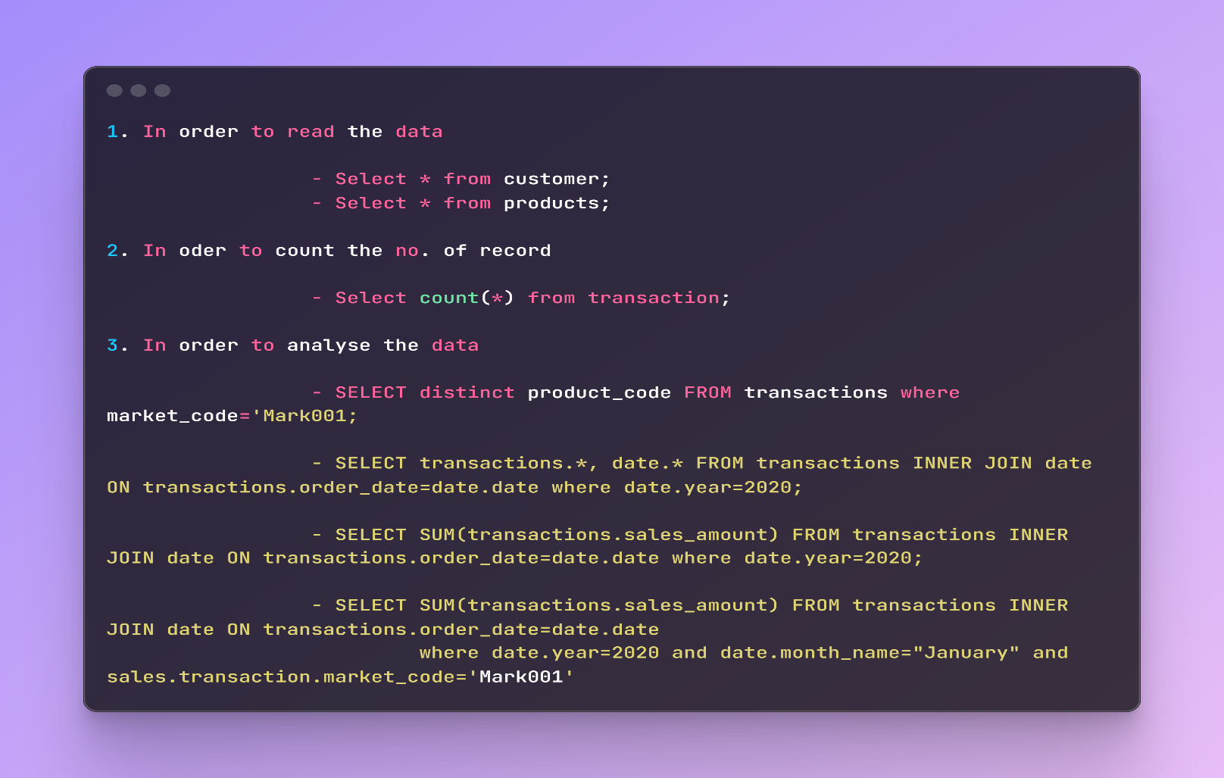

**Step 2 : Loaded data into Power BI Desktop from SQL.**

**Step 3: Data Modeling:**

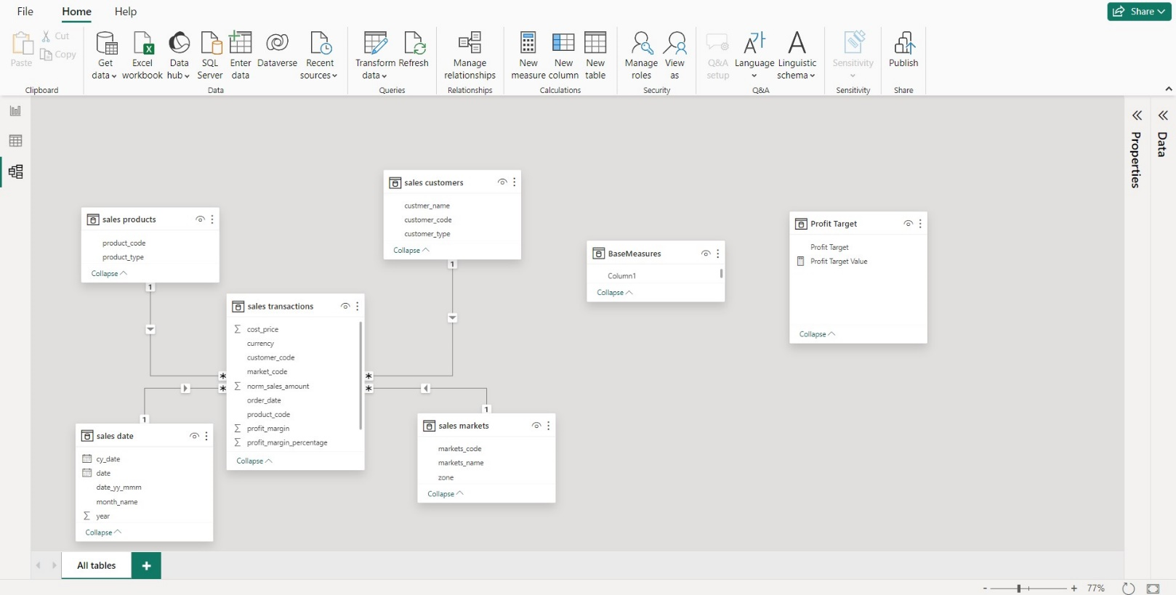

**Connected five tables to establish relationships:**

* **Sales Transactions (Main Table) connected to:**
  + Sales Customers (customer_code).
  + Sales Date (date).
  + Sales Products (product_code).
  + Sales Markets (market_code).

**Step 4: Data Cleaning and Transformation**

1. Removed invalid values in the `sales_amount` column (-1 and 0) to reflect actual sales data.

2. Standardized currency values in the `currency` column, converting USD to INR and handling hidden characters.

**Step 5: DAX Calculations**

**Profit Margin %:**

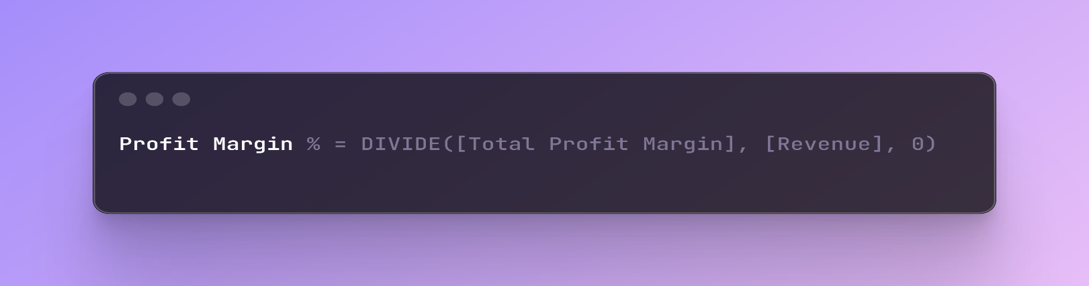

**Revenue Contribution %:**

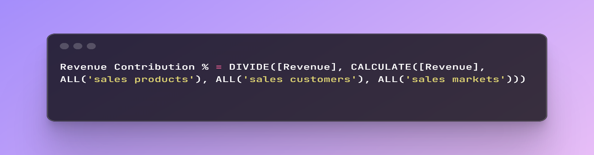

**Profit Margin Contribution %:**

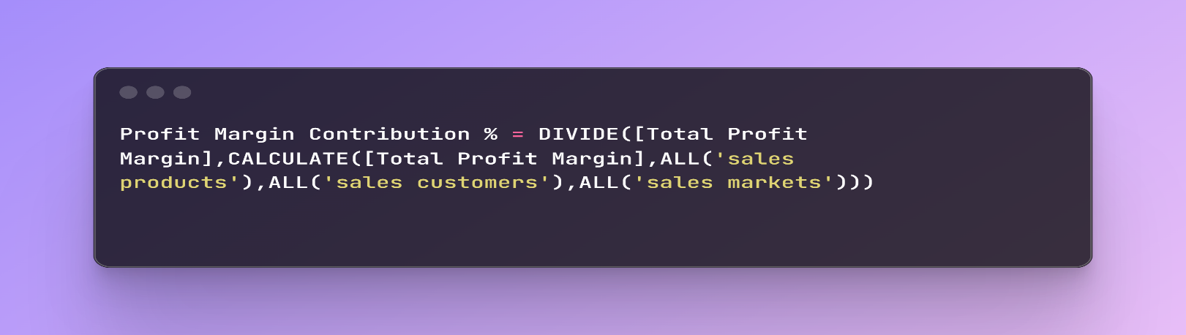

**Revenue:**

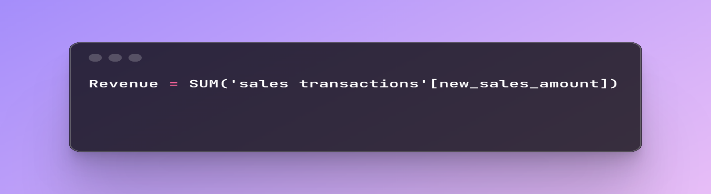

**Revenue LY:**

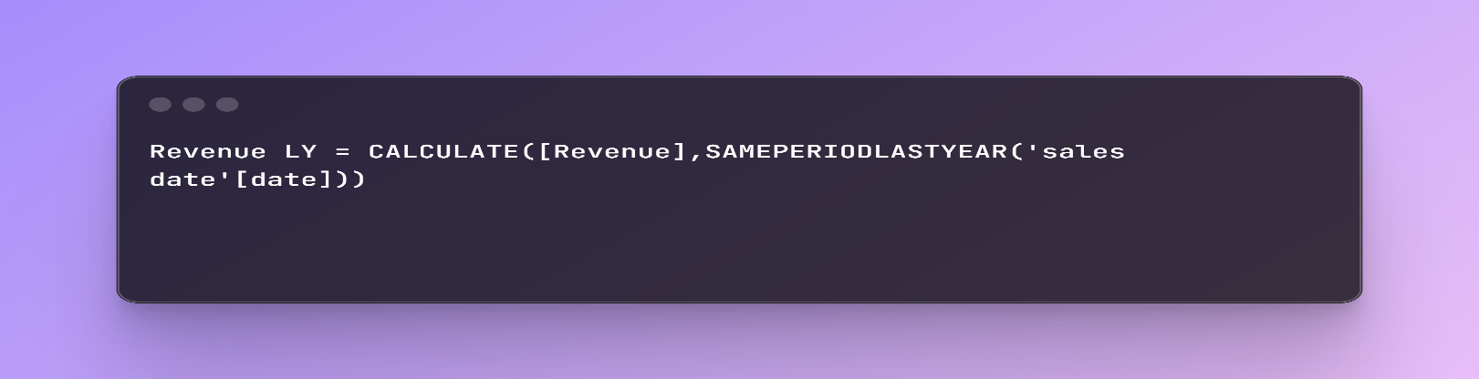

**Sales Qty :**

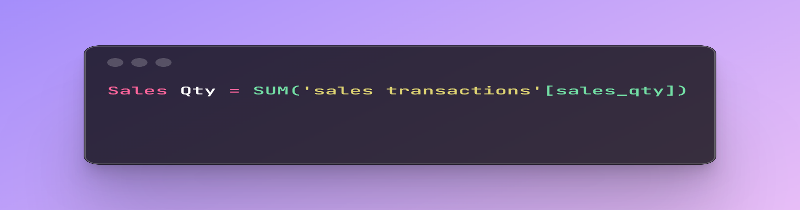

**Target Diff:**

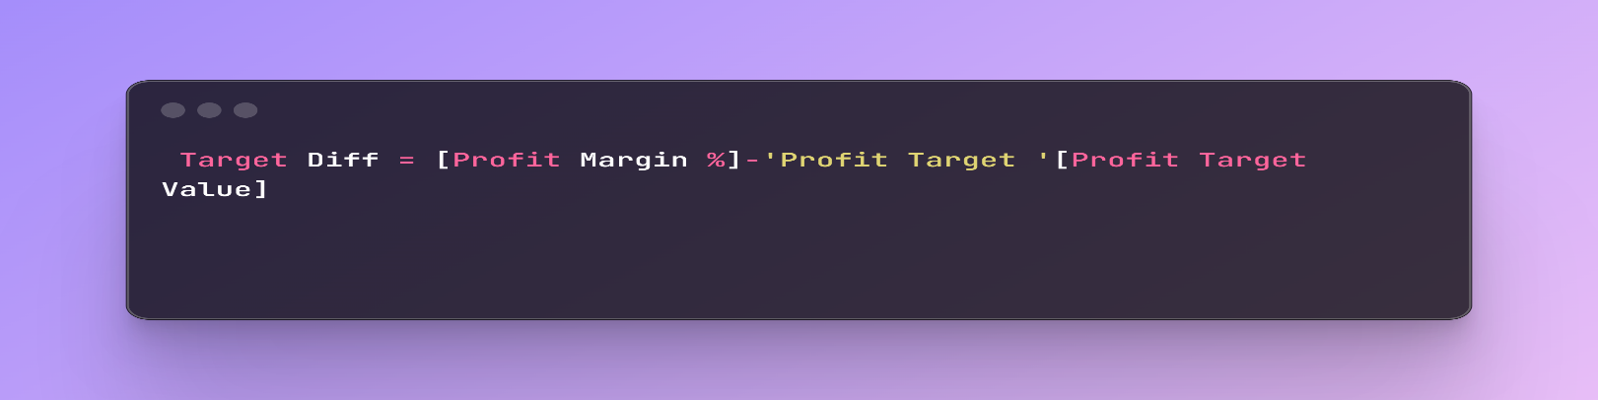

**Total Profit Margin :**

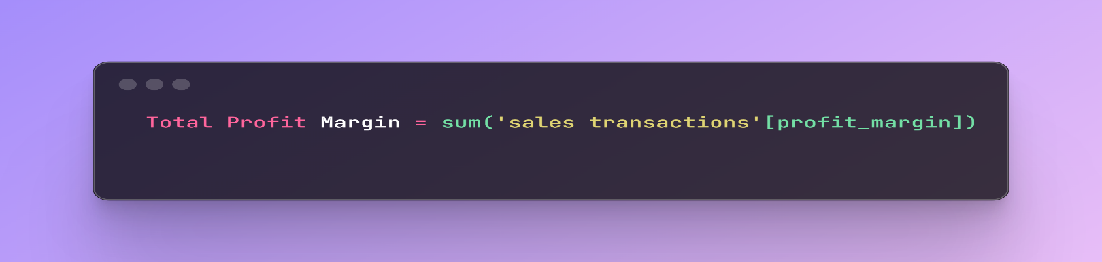

**Step 6:** **Dashboard Design**

Created three key report pages:

**1. Key Insights:**

Overview of the most important findings and trends.

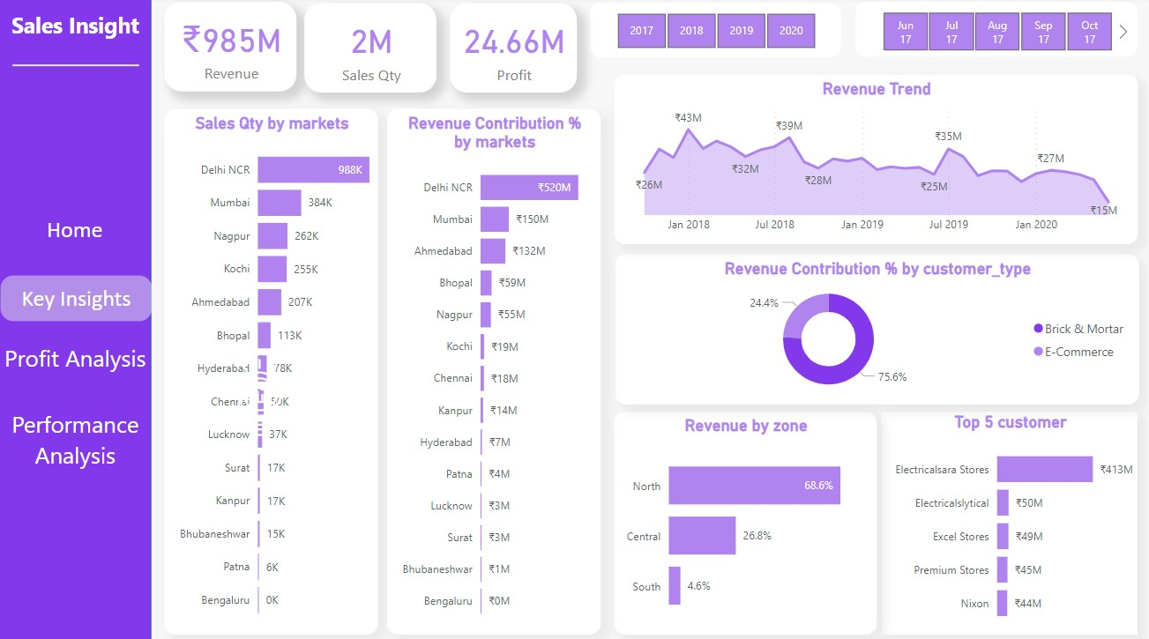

**2. Profit Analysis :**

Detailed financial analysis, including profit margins and contributions.

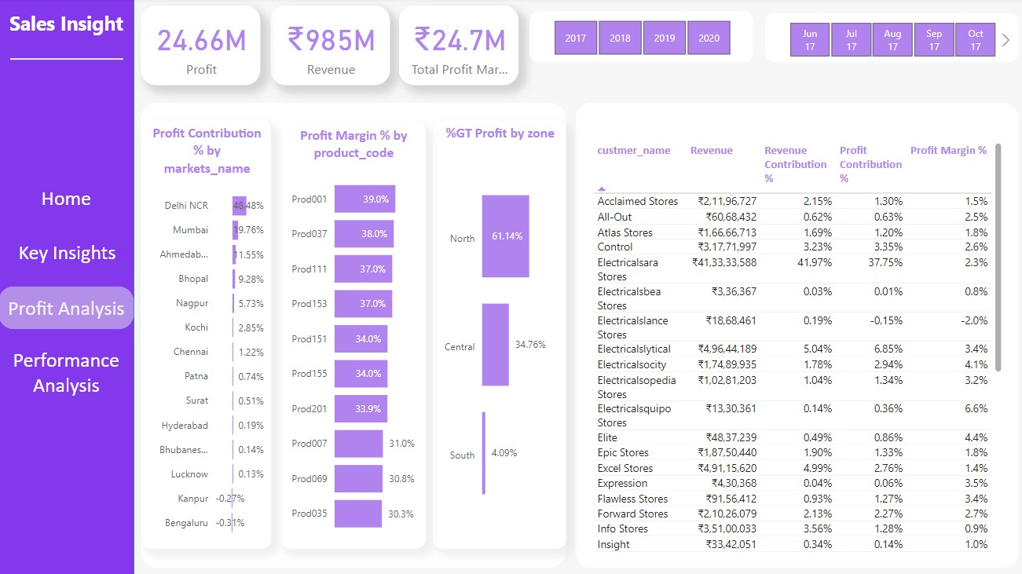

**3. Performance Analysis:**

Operational performance metrics, covering sales quantity, revenue, and year-over-year performance.

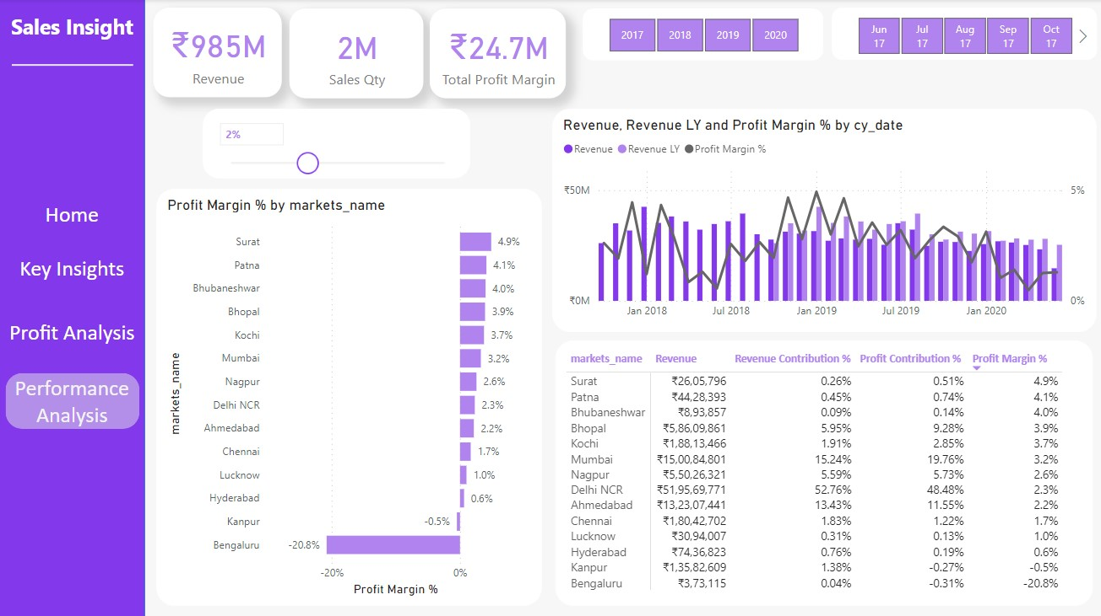

**Step 7: Insights Gained from the Project**

* Learned how to clean and transform data effectively.
* Gained insights into using Power Query for better data manipulation.
* Improved understanding and use of DAX functions for analysis.
* Successfully applied SQL queries to extract useful information.